Prediction

Making decisions based on predicting the actions of another vehicle.

If we were at a stop sign and see another vehilce on the left side of the intersection, we would need to understand that the car can possibly go straight or make a right turn.

With a probability distribution of each possible action that a vehicle can take, we would have a multi-modal distribution that peaks for both going straight and making a right turn.

That probability distribution comes from where the car is likeyly to be in 5 seconds.

In general the way we think about handling multi-modal uncertainty is by maintaining some beliefs about how probable each potential mode is.

Using prior knowledge about an intersection can help handle multi-modal distributions.

We can also use some information about a vehicle slowing down as it approaches the intersection increases the probability that the vehicle will make a right turn rather than go straight.

Until we can predict with a high certainty that one decision is being made by another vehicle, no desicisons are made.
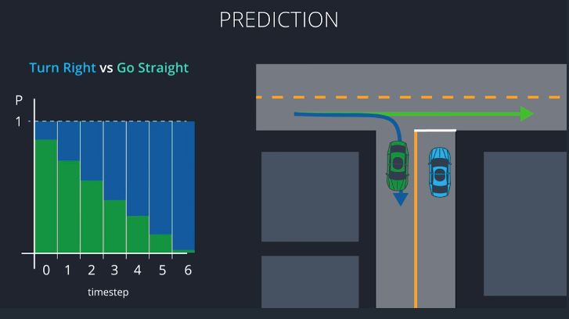

With map the map and sensor fusion data, we require our prediction module to be able to give us probability predicitions of the future state of every vehicle and moving objects in the vacitnity of the vehicle.

Usually the predicions are represented as possible trajectories.
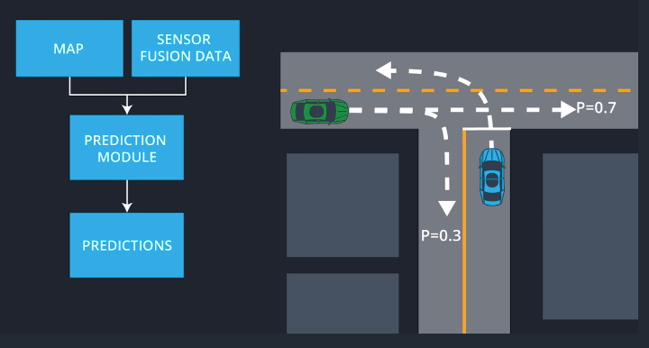

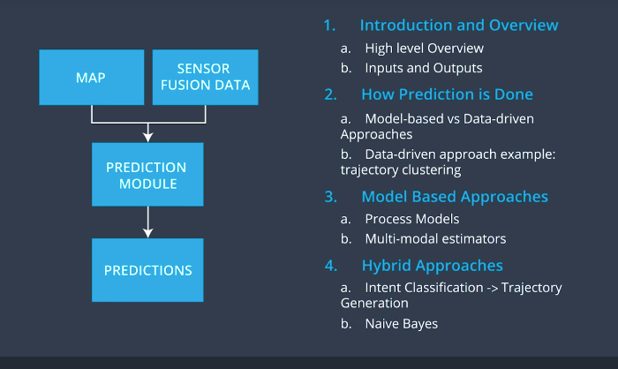

Model-Driven approach
Use mathimatical models of vehicles to predict trajectories.

Data-Driven approach
Rely on machine learning and examples to learn from.

I/O For Prediction Module

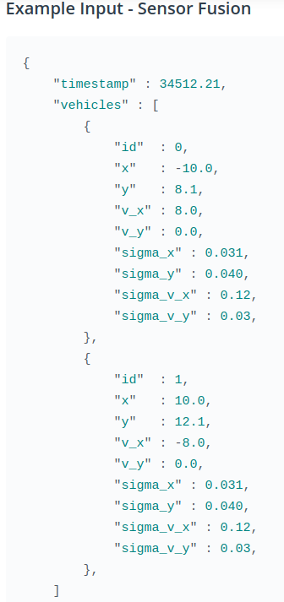

Output JSON is in another file.

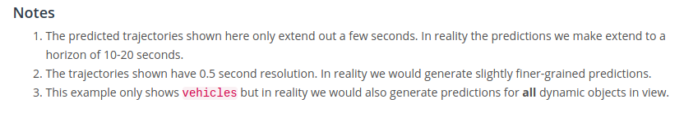

Model-Based Vs Data-Based Approaches

A Model-based approach for prediction invovles having 2 different process models for a car going straight, or the car taking a right turn. We would use a trajectory generator to generate a trajectory of the car going straight, or the car taking a right turn.

Afterwards, we observe the behaviour of the vehicle actually takes.

We would then use a Multimodal Estimation Algorithm to compare the actual trajectory taken by the vehilce to the 2 predictions we made earlier with our models. Based on the comparison, we assign a probability to each of the trajectories.

The key take away from this process is that for a model approach we are required to have a bank for each possible behaviour, each with their own mathimatical model of motion that takes into account the physical cababilites of the objects, as well as the constraints imposed by the road traffic laws.

With a Data-driven approach our alogrithm will be a truely black box algorithm. The alogrithm will be trained with lots of data of observations and output their predicted trajectories.

Once it is trained we just feed it the observed behaviour and we rely on the predicted trajectory output by our machine learning alogrithm.
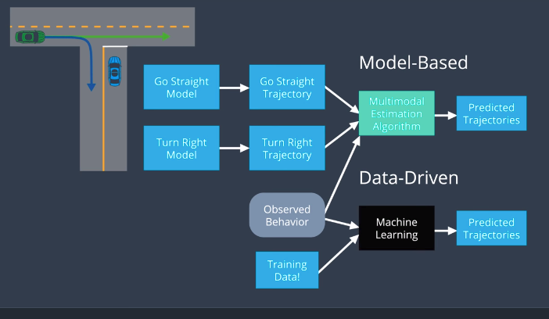

Model-based Advantages:
- Incorporate our knowledge of physics along with the costraints based on the road like traffic laws

Data-Driven Advantages:
- Use data to extract subtle patters that would otherwise be missed by a model-based approach. Example: vehicle behaviour at an intersection at a given time of the day.

No approach is strictly better than the other, but there are certain situtations where one approach is better than the other.

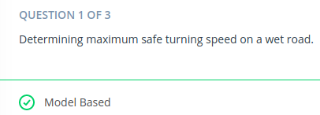

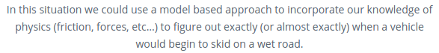

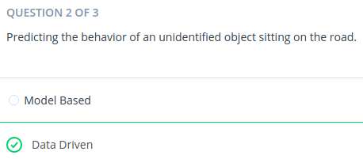

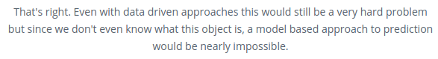

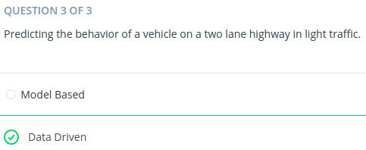

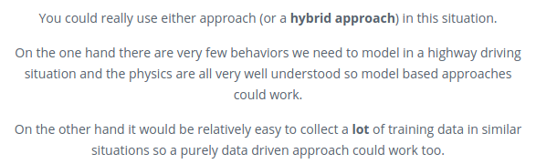

Data Driven Example

There are many different ways that manchine learning can be applied to a data-driven approach.

One example that is representative of what they are like is called Trajectory Clustering.

Like any machine learning data-driven application, there are two phases.

1) The offline training phase, the phase where your algorithm trains and learns a model from data.

a) The first step is to get alot of training data. This is usually done by placing a static camera at an intersection.
b) Clean the data to be usefull information rather then cars that get occluded, or something going wrong in the processing step. (Leaving us with usefull vehicle trajectories)
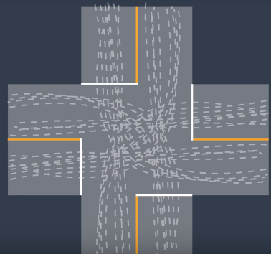

c) Define a mathematical measure of similarity. This will be used to compare and categorize which trajectories are of a vehicle going straight, and which are turning left or right. This is a complicated step, but it is important to train a model. A paper detailing how is in the directory.

d) We can use a mchine learning algorithm to perform unsupervised clustering. Example: agglomerative clustering, or spectral clustering. What we expect from the output is 12 clusters of data for a 4 way intersection, due to each side being able to perfrom 3 actions that lead to 3 different trajectories per stop. If a traffic light is at the intersection, clustering will probably differentiate between cars going through the intersection, and cars stopping for the light. This will result in 6 trajectories per stop instead of 3.

e) Now that our trajectories are grouped into clusters, it is useful to define what prototype trajectories look like for each cluster. Example: a trajectory of what a left turn would typically look like represents the left turning cluster.

Now we have a trained model for trajectories at this particually intersection. Now we need to use this model to generate predictions.

2) The online prediction phase, the phase where that trained model is used to generate a prediction.
Now that our clustering algorithm has identified clusters and prototype trajectories, in the image below 3 clusters are shown with 3 prototype trajectories each, we can now compute Online prediction for vehicles we meet on the road.
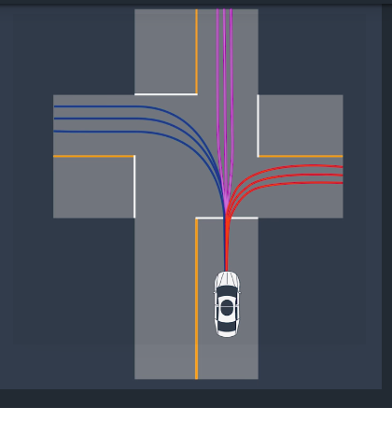

For every update cycle we:
a) Observe a vehicles partical trajectory.
b) Compare it to the corresponding segments of the prototype trajectories. (same algorithm used for clustering)
The belief for the vehicle is updated based on how similar the partial trajectory is to the prototype trajectories.
c) Compute a predicted trajectory for each cluster, for example by taking the most similar prototype trajectory.

Example:
Time step where a vehicle is stopped at the stop sign has the vehicles trajectory overlapping all of the clusters of the prototype trajectory, making the belief for each cluster 1/3.

We then choose the best prototype trajectory of the highest belief cluster to represet the vehicles future trajectory.

As the process continous the clustering belief goes to 0.99.

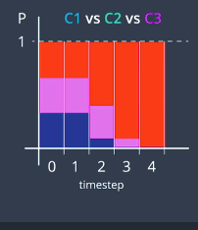
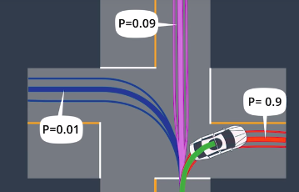

When we have accesss to plenty of training data, Data-driven approcahes are very useful.

Howevery, only using a data-driven approach is naive due to the fact that it only relies on historical data to predicte future behaviour.

Ideally we would also like to include in our predictions, all our insights about driver behaviour, physics, or vehicle dynamics. Model-based approaches help account for these things.

Model-based approaches

For each Dynamic Object nearby:

1) Identify all the common driving behaviors that the object is likely to do at the current situation. (Change lanes, turn left, cross street, etc) If the object is a person, it may be cross the street.

2) Define a process model for each behaviour. The process model is the mathematical description for the objects behviour and let us calculate the objects position at time t + 1. The process model incorporates uncertainty of how much we trust our model.

3) Use the process models to compute the probability of each behaviour. This is done by the observed state of the object at time t -1, and using the process model to predict the state at time t.

4) We then compare the observed state at time t to what our process models predicted. We use a multimodal estimation algorithm to derive the probability of each maneauver.

5) Predict the trajectory for each behaviour by iterating on the process model until the prediction horizon.
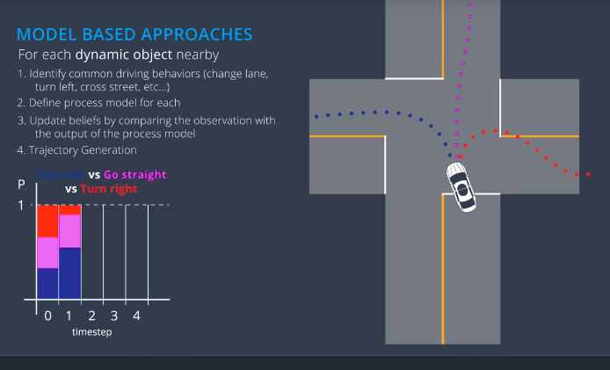

Frenet Coordinates

- a way of representing position on a road in a more intuitive way than traditional x, and y Cartesian Coordinates.

We use variables s and d to describe a vehicles position on the road.

S – distance along the road (Longitudinal Displacement)

D – side-to-side position on the road (Lateral Displacement)

Look at a curvy road represented in Cartesian Coordinates
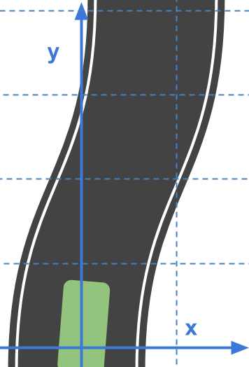
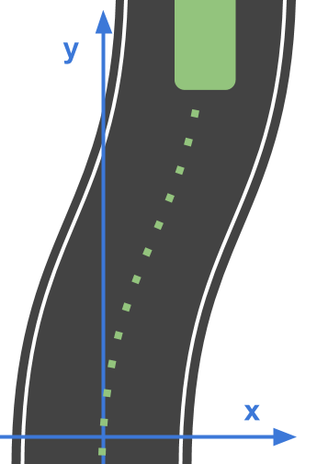

With paths this curvy, if we wanted equations to describe the motion, it wouldnt be simple equations.

This new coordinate system helps describe this mathematically easy.
Frenet Coordinates:

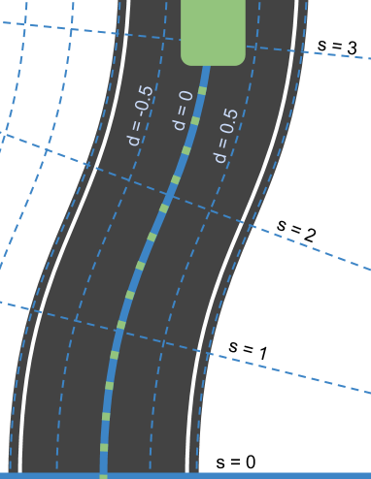
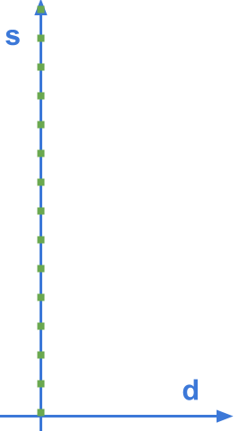

Being straight on the road is now represented has a staight line.

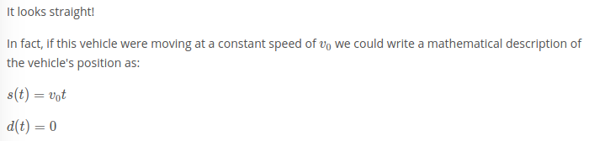

Process Models

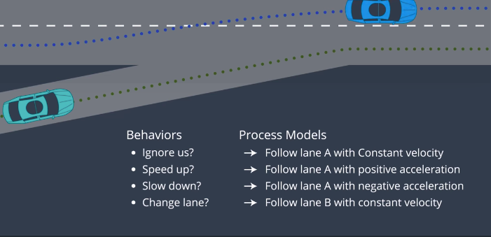

First we must determine possible behaviours of another vehicle at the current situation, and generate a process model for each possible behaviour.

Lane Following, what our process model should have represented.

There is a wide variety of Lane follwoing process models we can use, but there is tradeoff between simplicity, and accuracy.

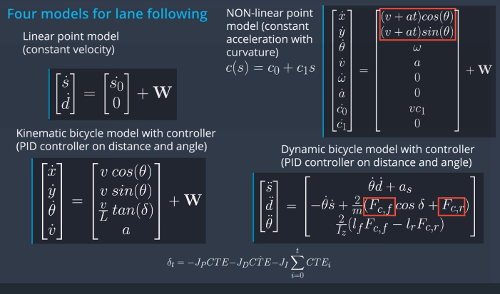
With prediction, there is inherently so much uncertainty associated that using the most complex model usually isnt worth the computional time.

W is how we represent the models uncertainty. It is usually a multivariate gausssian with 0 mean.
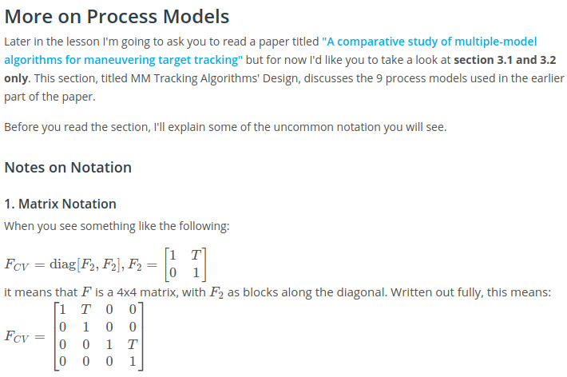
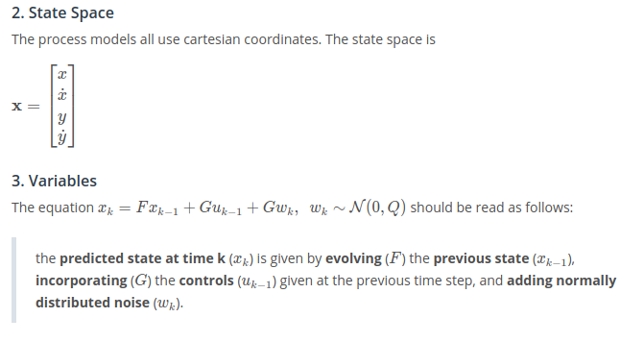

Autonomous Multiple Model Algorithm – Variables

We havent talked about how to maintain beliefs about which behaviour a driver intends to perfrom. That is where a multimodal estimation algorithms come in.

A simple approach to multimodal estimation is called the Autonomous Multiple Model Estimation Algorithm (AMM).

Variables:
- M represents the number of process models or behaviours
- Probabilies of behaviour for each process model are u1....uM

Example: We are at a stop sign and need to predict the behaviour of another vehicle. It can either go straight, or turn right.

Two process models with gaussian uncertainties are used to represent both behaviours.
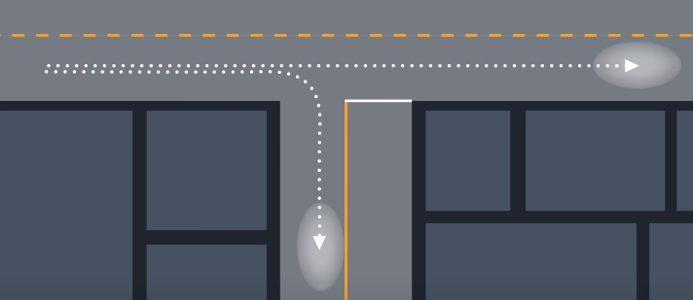

We use our observations of the vehicles state at timestep k and timestep k-1.

In order caluclate the new probabilites for the behaviours based on the new observation, we need to run both our process models for one step k-1, which will leave us with the predicted states for each process model at time k.
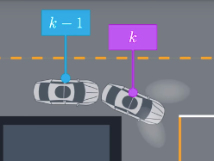

If we look at what the probability distribution function looks like for just the S-coordinate using Frenet coordinates, we can see that at our observed s value, the probability of going right is higher than the probability of going left. This ratio is used to calulate the belief of what the driver will do at the timestep k.

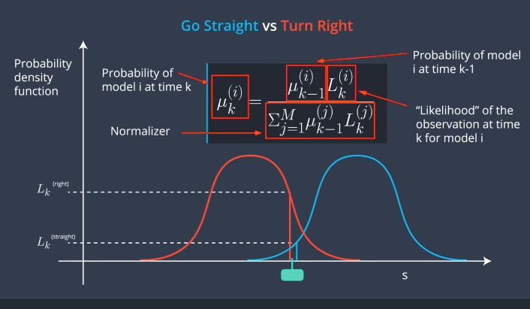
The ratio takes the probability of the previous timestep, and lets us calculate the probabilty of the next timestep by using the likelihood of each model.

The normalization ensures that the probabilites for all the behaviours adds up to 1.

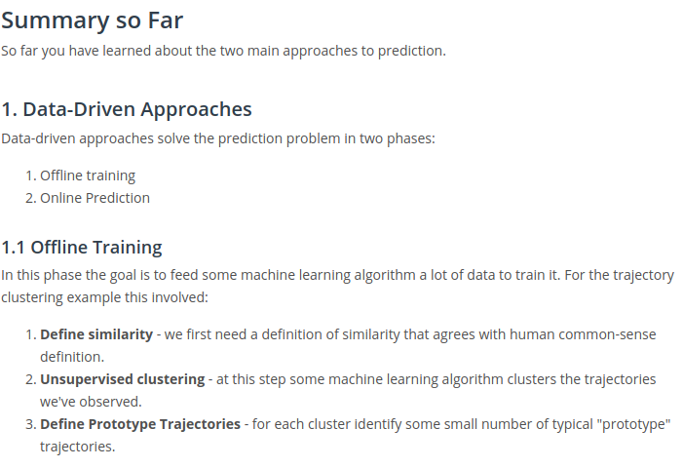
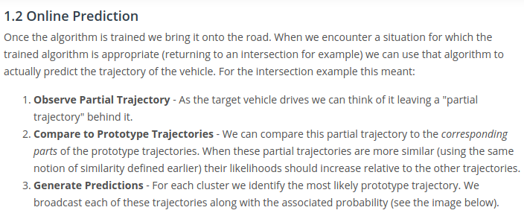

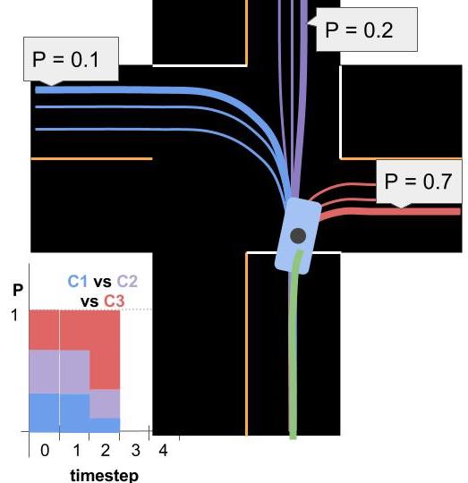

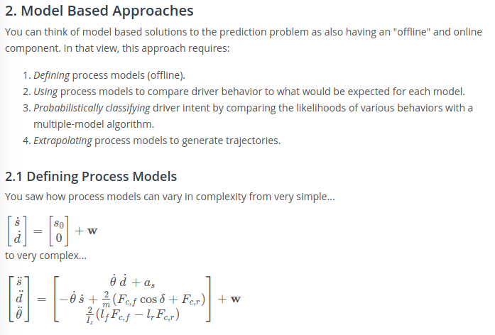

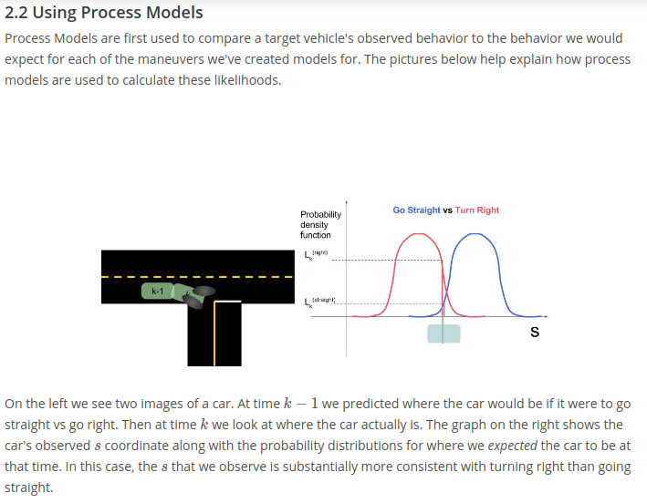

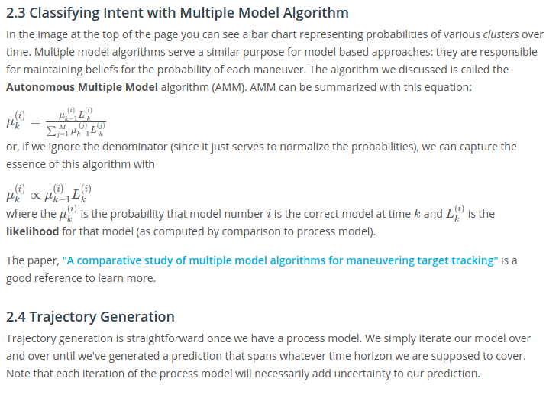
Overall:
To use model based approaches you need mathematical models describing the objects motion for each type of behaviour.
We also handle unceratinty on maneauvers using multimodal estimation.

With Data-driven, there are a wide variety of versions, and they extract subtle patters from training data very well.

Hybrid Approaches

Hybrid approaches are most often the best approach.

Model based combines process models with a multimodal estimator. If we used the same idea but replaced the multimodal estimator with a machine learning approach, the solution become a hybrid approach.

The type of machine learning algorithm we would need to replace a multimodal estimator is a classifier. One example of a classifer that can be used is the Naive Bayes, or the SVM (support vector machines).

